ICS4M0 – Using Arrays

1. What is the disadvantage of creating an array that is larger than the number of values that we intend to put into the array?

The array’s size cannot be changed after it has been declared. It does not have the ability to increase or decrease the amount of memory allocated to it.

1. What would be printed by the following program fragment?

int[] list = new int[4];

for (int i = 0 ; i < list.length; i++)

list[i] = 3 – i;

System.out.println(list[1]+2);

System.out.println(list[1+2]);

System.out.println(list[1]+list[2]);

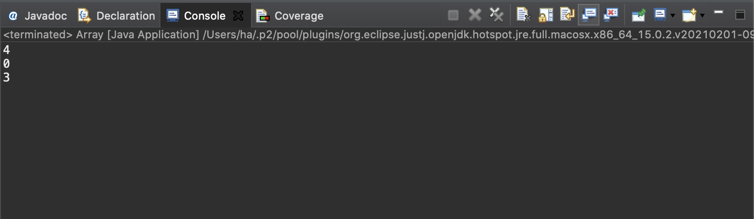

1. Suppose that an array sample has been declared as follows:

int[] sample = new int [SIZE];

Write one or more statements to perform each task.

1. Initialize all elements of the array to one.

int[] sample = {0, -1, 3, 5, -4};

int[] sample = new int [5];

1. Switch the values at either end of the array

int[] sample = {-4, -1, 3, 5, 0};

1. Change any negative values to positive values (of the same magnitude).

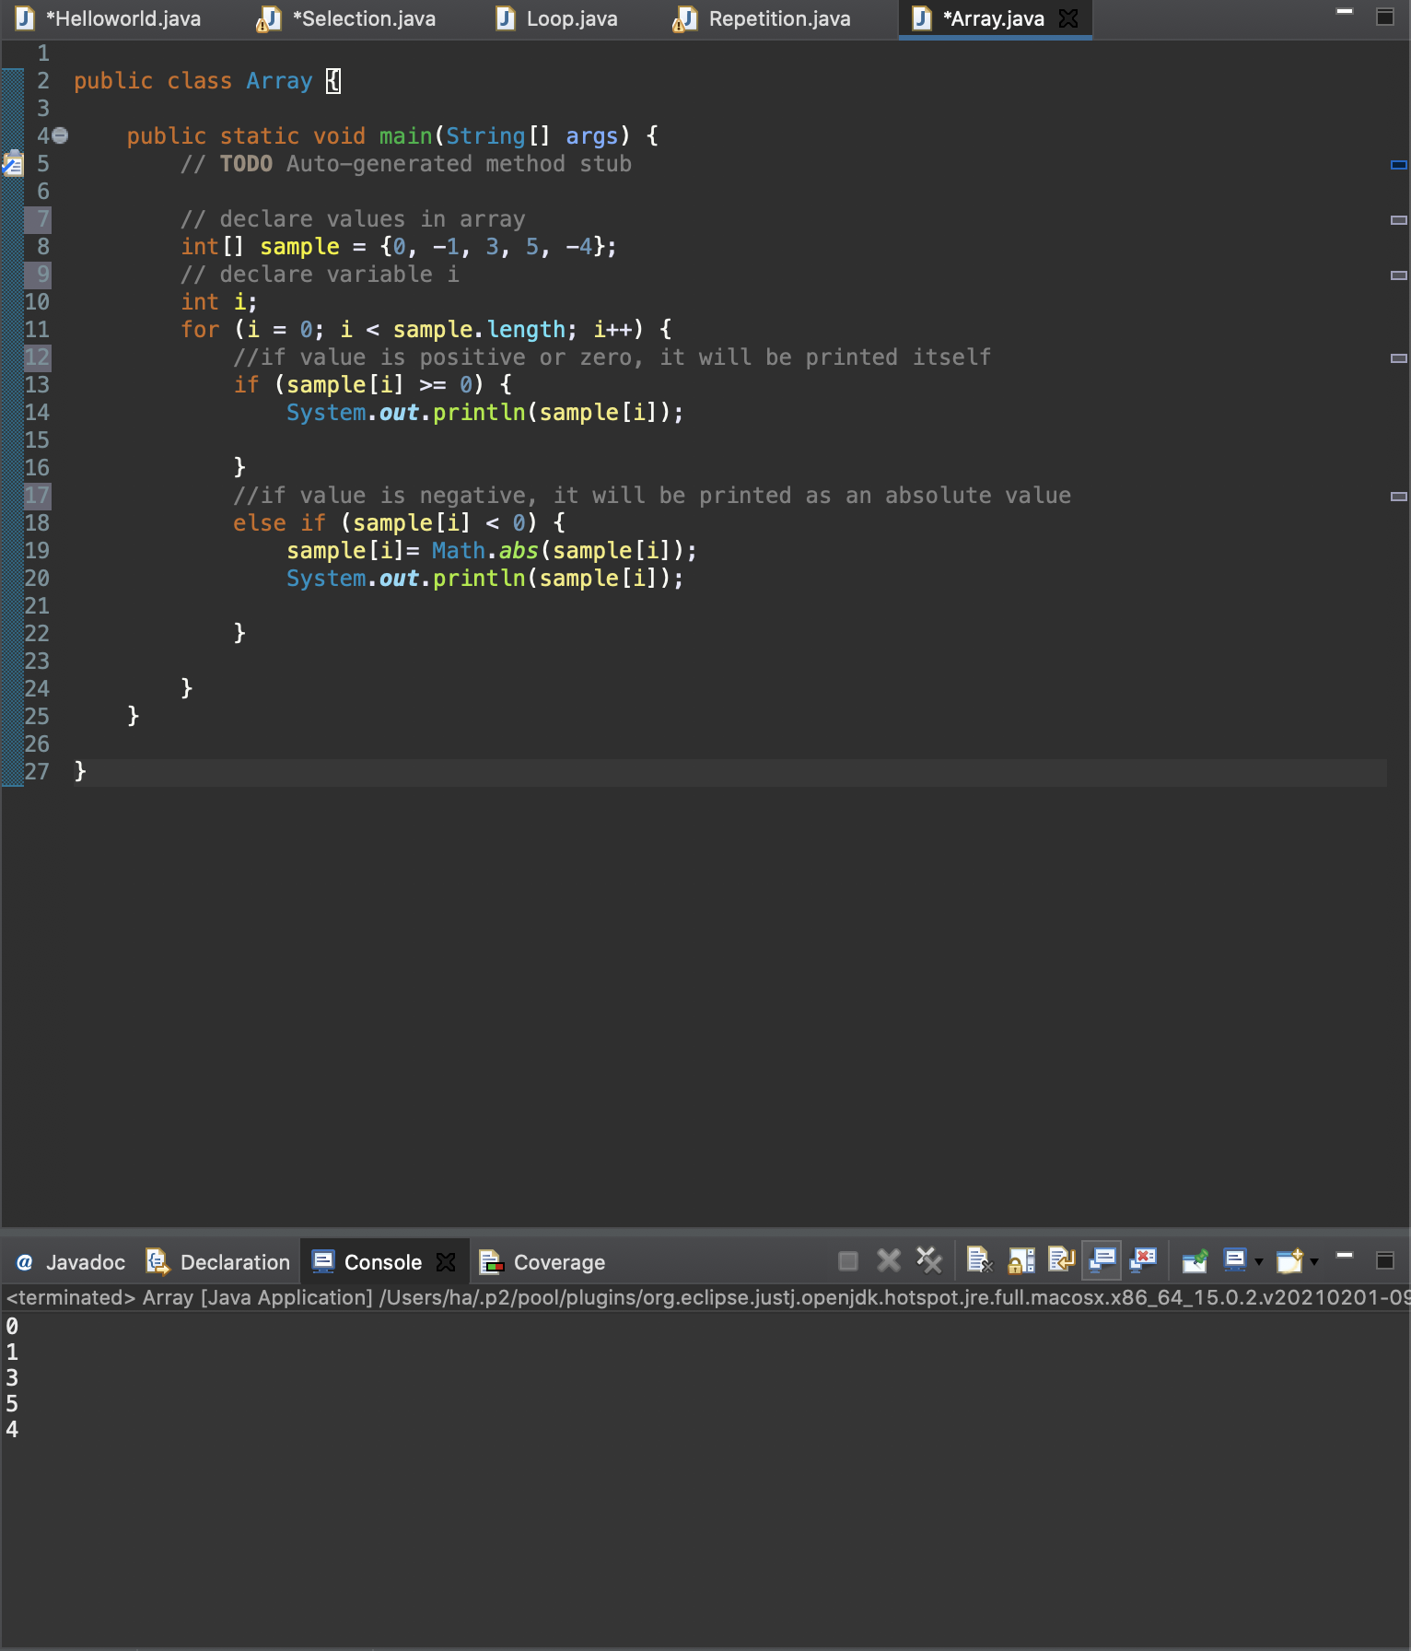

1. Set the variable sampleSum to the sum of the values of all the elements.

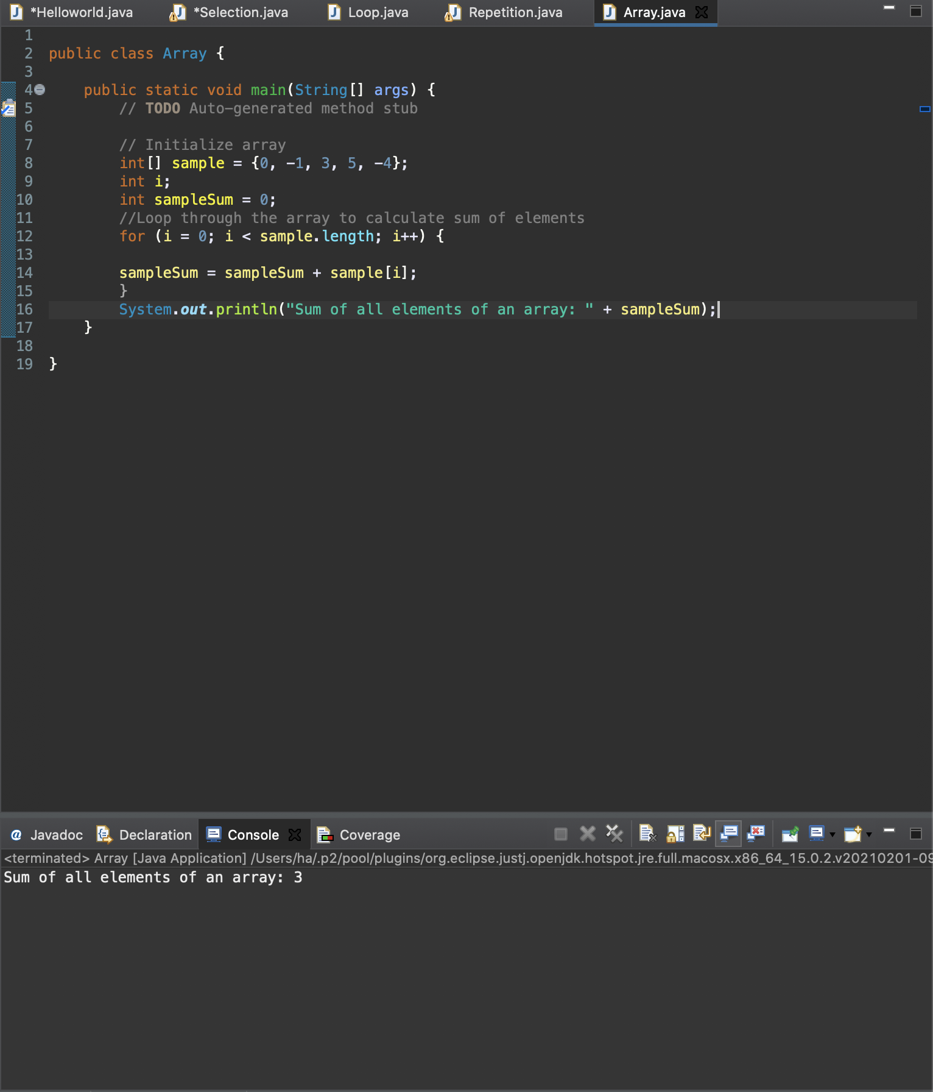

1. Print the contents of the odd-numbered locations.

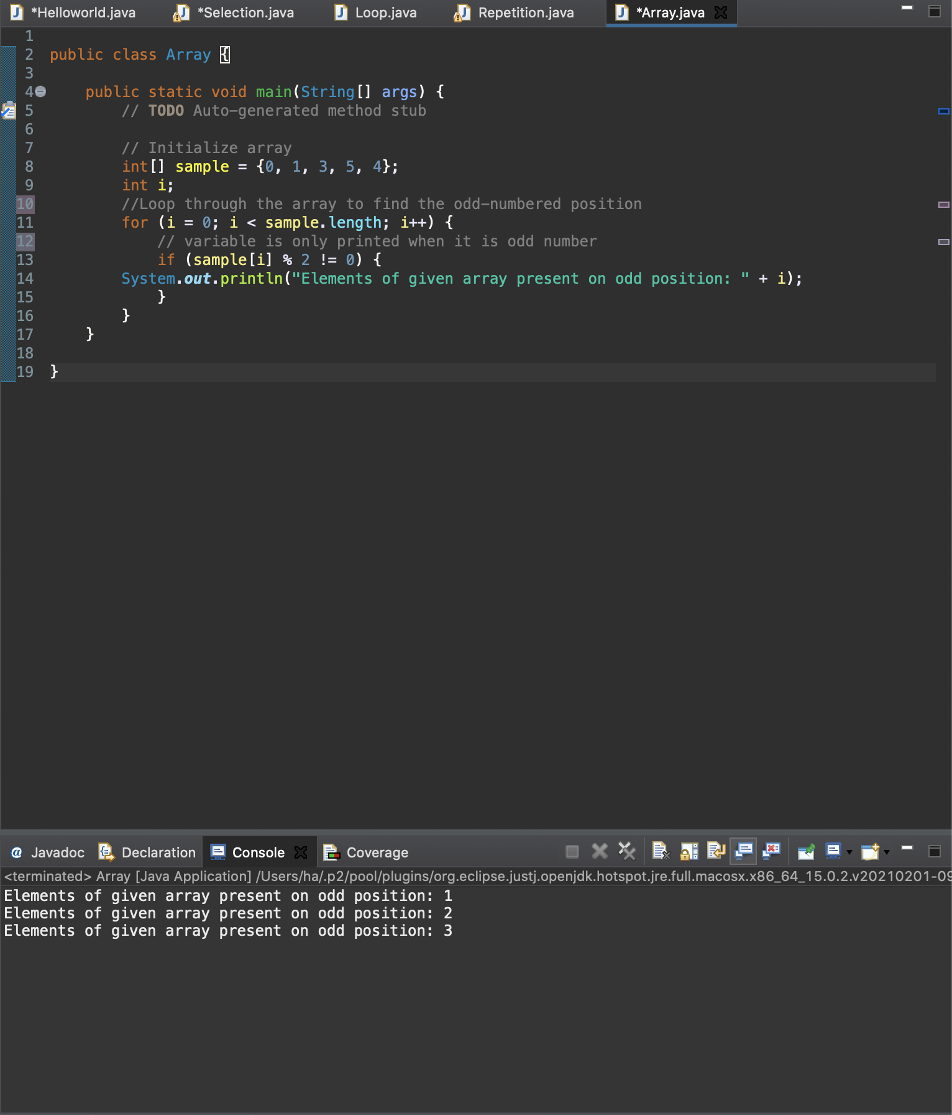

1. Write a segment of code that will locate the largest element in an array

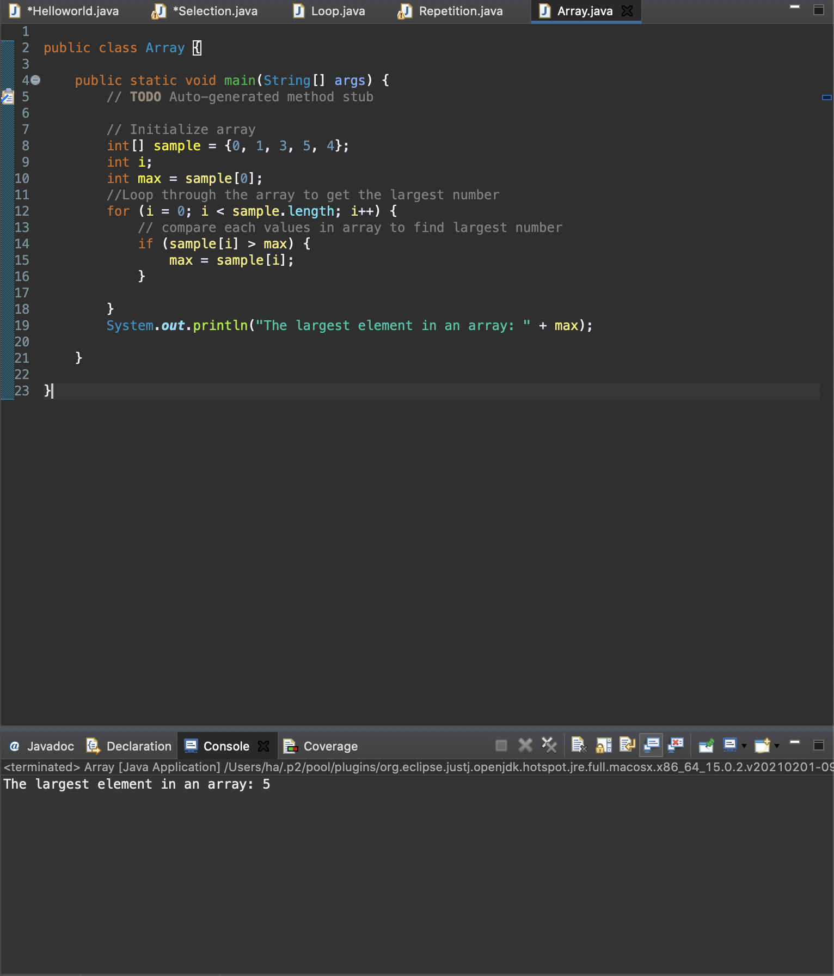

1. a) Write a program that repeatedly prompts the user to supply scores (out of 10) on a test for a class of 12 students. The program should continue to ask the user for marks until a negative value is supplied. Any values greater than ten should be ignored. Once the program has read all the scores, it should produce a table with the following headings

Score # of Occurrences

The program should then calculate the mean score rounded to one decimal place.

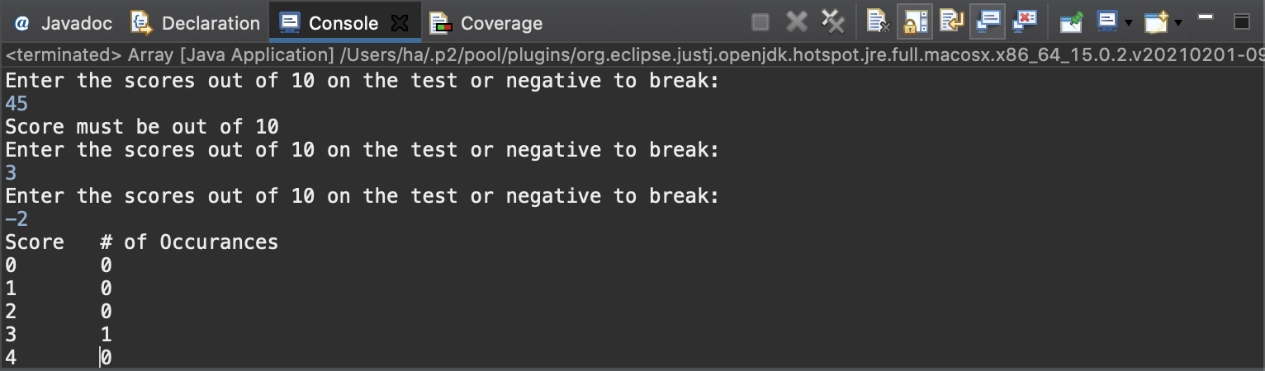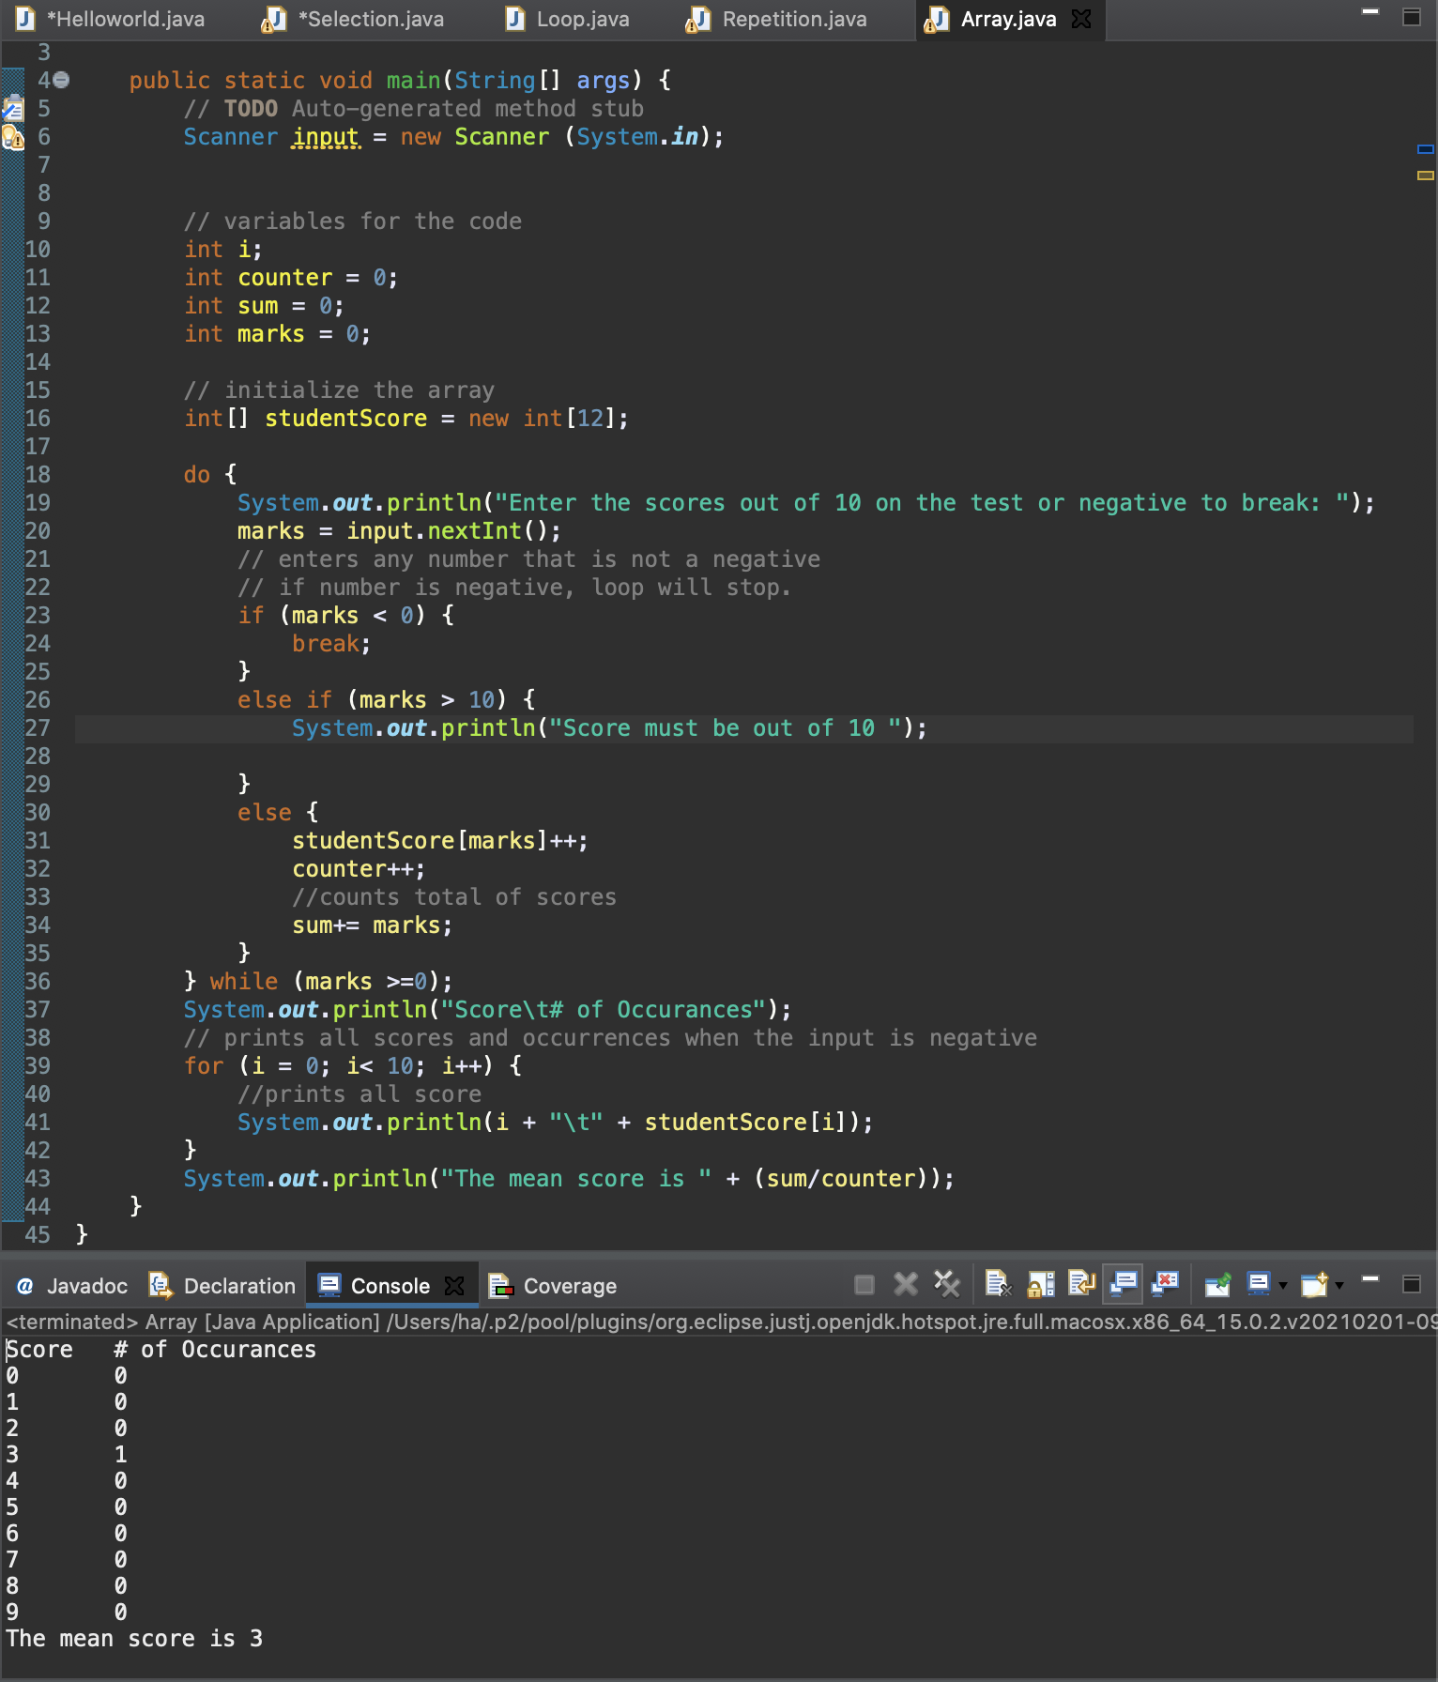

b) Modify the program to adjust the test score to be out of 15. Any values greater than 15 should now be ignored. (If you planned your variables wisely, you should only need to change one line!)

